Measles resources for Primary Care
29/01/2024
NHS Lincolnshire Integrated Care Board have developed a Measles Elimination Strategy and Action Plan to identify areas for improvement to increase MMR vaccination uptake to achieve and maintain elimination status and to protect the population of Lincolnshire against the risk of localised Measles outbreaks.
Here is what we need from you!
- Display posters in waiting rooms to raise awareness of the symptoms of Measles and the importance of the MMR vaccine. (Free copies available here: Think Measles Poster for A&E, Walk-in and GP Centres - Health Publications). Links and QR codes provided in “useful links” section.

- Ensure all staff are aware of the signs and symptoms of Measles and are familiar with the process of managing suspected or confirmed cases in Lincolnshire (Lincolnshire System guidance and all National guidance and resources, including leaflets, posters, videos etc are available on the IPC Link Practitioners NHS Futures page).

- Encourage patients with symptoms of Measles to avoid attending a healthcare facility unless advised by a clinician following remote assessment.

- If Measles is suspected, report to UKHSA following the standard process for notifiable diseases. UKHSA will send a testing kit out to the patient.

- If face to face assessment is required, avoid any contact with other patients and direct patient to an isolation room for assessment. Staff assessing the patient should use respiratory protective equipment (RPE) as advised by NHSE. NHS England » Guidance for risk assessment and infection prevention and control measures for measles in healthcare settings.

- Where suspicion is made upon face to face assessment, follow practice isolation procedures, contact UKHSA as above. Staff should know that any patients with fever and rash are potentially infectious and take appropriate action to stop onward transmission without delay, including PPE. Commence contact tracing (patients exposed in the waiting room, staff exposed etc). Contact tracing template is available on the IPC Link Practitioners NHS Futures page. Face-to-face contact of any length or more than 15 minutes in a small, confined area is considered as exposure and will require follow-up.

- Offer MMR vaccine to patients who do not have documented evidence of complete MMR vaccination (2 doses) opportunistically, using the principles of MECC. Identifying people eligible for vaccination and opportunistic vaccination (nice.org.uk)

- Patient- facing staff should have documented evidence of 2 doses of the MMR vaccine or have positive antibody tests for measles and rubella, according to national guidance: https://assets.publishing.service.gov.uk/media/5a7abc09e5274a319e77a5b9/Green-Book-Chapter-12.pdf

- Encourage the IPC Link Practitioner and/or Deputy, to share the information being made available on the IPC Link Practitioner NHS Futures platform. If access is required, please contact the ICB Health Protection Team: licb.lincsipc@nhs.net.

- Encourage good hand hygiene practice amongst all staff and patients.

Useful links:
Lincolnshire Primary Care Infection, Prevention and Control - FutureNHS Collaboration Platform
National measles guidelines January 2024 (publishing.service.gov.uk)
NHS England » Guidance for risk assessment and infection prevention and control measures for measles in healthcare settings.(Version 1.1, 24th January 2024.)

Link to download posters/leaflets in other languages:
Measles outbreak resources - GOV.UK (www.gov.uk)

NHSE Letter to GP’s, 17th October 2023:

NHS England » Guidance for risk assessment and infection prevention and control measures for measles in healthcare settings (Appendix 2: Think Measles – primary care actions for screening, triage and management):
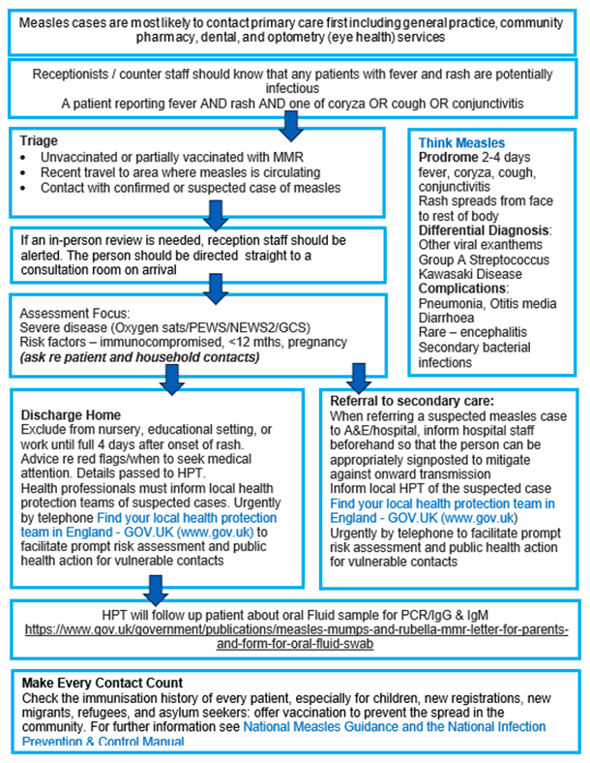

Measles outbreak A4 poster for GP surgery reception (publishing.service.gov.uk) including QR code:
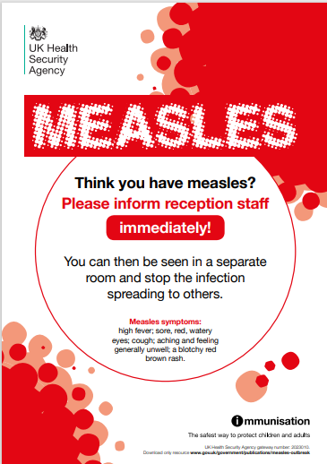

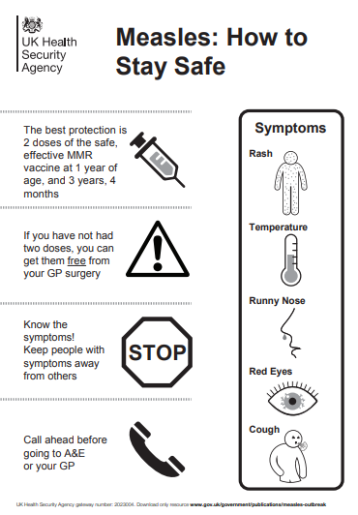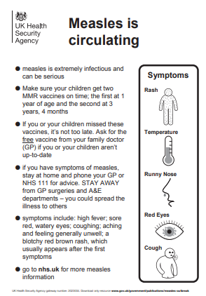

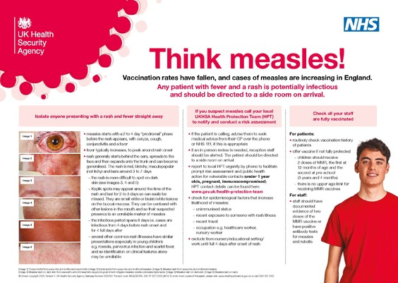
Think Measles Poster for A&E, Walk-in and GP Centres - Health Publications

